**Chapter 10 Homework**

1. A vinyl record plays at 33.3 rpm. Assume it takes 5 sec for it to reach this full speed, starting from rest.

1. What is its angular acceleration during the 5 sec?
2. How many revolutions does the record make before reaching its final angular speed?

2. Consider a 53 cm long lawn mower blade rotating about its center at 3400 rpm.

a. Calculate the linear speed of the blade.

b. If safety regulations require that the blade stoppable within 3 sec, what minimum angular acceleration

will accomplish this? Assume that the angular acceleration is constant.

3. The angular acceleration of a wheel, as a function of time, is (t) = 5t2 – 8.5t, where  is in rad/sec2 and t in seconds. If the wheel starts from rest ( = 0,  = 0, at t = 0) determine a formula for the angular velocity, , as a function of time and the angular position, , as a function of time. Evaluate  and  at t = 4 sec.

4. Calculate the net torque about the axle of the wheel shown. Assume that a friction torque of 0.25 mN opposes the motion.

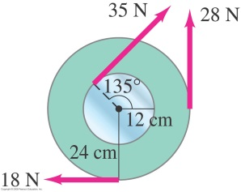

5. A baseball player swings a bat, accelerating it from rest to 3 rev/sec in a time of 0.2 sec. Approximate the bat as a 2.2 kg uniform rod of length 0.95 m, rotating about an axis 0.25 m away from the handle of the bat (this axis may be in the air and not on the bat). What torque does the player apply to the bat?

6. The forearm shown below accelerates a 4 kg ball at 7.5 m/sec2 by means of the triceps muscle.

a. What force is applied to the ball (yes, this is a question that could have been solved in Ch. 4)?

b. Calculate the torque applied by the triceps muscle around the elbow.

c. Calculate the force applied by the triceps muscle. (You may want to draw these forces on the diagram

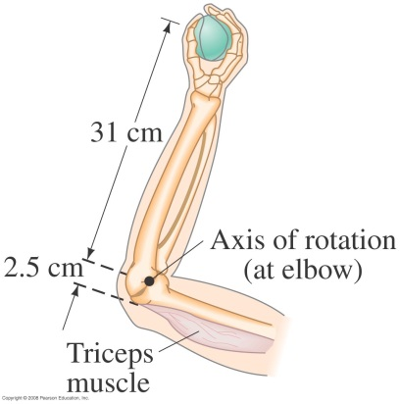 below.)

7. A thin hoop of radius r0 = 24.5 cm and mass 1.2 kg starts from rest and rolls without slipping down a 30o incline that is 10 m long.

a. Calculate the translational and rotational speeds when it reaches the bottom.

b. If the surface is frictionless, what is the velocity of the hoop when it reaches the bottom?